Measures of Central Tendency

The central tendency is measured by averages. These describe the point about which the various observed values cluster.

In mathematics, an average, or central tendency of a data set refers to a measure of the "middle" or "expected" value of the data set.

Measures of Central Tendency: There are different types of measures of central tendency. Some of them given below-

- Arithmetic Mean
- Geometric Mean
- Weighted Mean
- Median
- Mode

Population Mean is the sum of all the population values divided by the total number of population values. Let 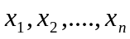 observations. So their Population mean is.
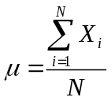
Where
- µ is the population mean
- N is the total number of observations.
- X is a particular value.
- 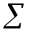 indicates the operation of adding.

The sample mean is the sum of all the sample values divided by the number of sample values:
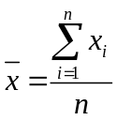
- is the sample mean
- n is the total number of observations.
- x is a particular value.
- indicates the operation of adding.

Arithmetic Mean

The arithmetic mean is the sum of a set of observations, positive, negative or zero, divided by the number of observations. If we have n real numbers 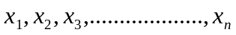 their arithmetic mean, denoted by, can be expressed as:
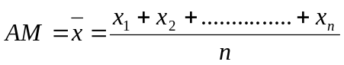
Or 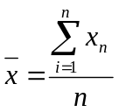

Properties of Arithmetic mean:
- It requires the interval scale or ratio scale.
- All values are included in computing the mean.
- It is unique. That is there is only one mean in a set of data.
- The sum of the deviations from the mean is 0.
Expressed symbolically: 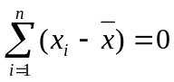
Proof: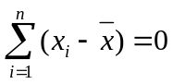
L.H.S=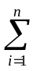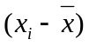
=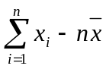
=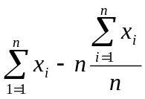; [We know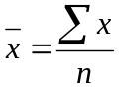]
=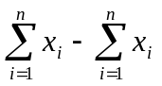
=0
=R.H.S

Uses and Limitations:
A.M is the most popular average in practice. But it is unduly affected by the presence of extreme values.

Weighted Mean:
The weighted mean is a special case of arithmetic mean. It occurs when there are several observations of the same value.
The Weighted mean of the positive real numbers 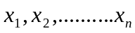with their weight 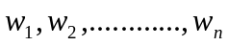is defined to be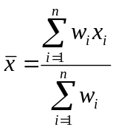.

Example: During a one hour period on a hot Saturday afternoon cabana boy Chris served fifty drinks. He sold five drinks for $0.50, fifteen for $0.75, fifteen for $0.90, and fifteen for $1.10. Compute the weighted mean of the price of the drinks.

Sol: 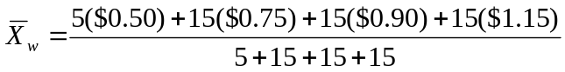
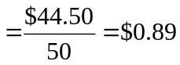

Median
The Median is the midpoint of the values after they have been ordered from the smallest to the largest or from the largest to the smallest.

If n is odd 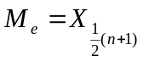
If n is Even 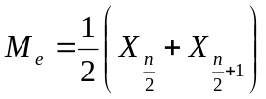

Example (for ungroup data):
Ex-1:
The ages for a sample of 11 college students are:
21, 25, 19, 20, 17, 24, 22, 18, 25, 20, 23.Find median.

Sol: Arranging the data in ascending order gives:
17, 18, 19, 20, 20, 21, 22, 23,24,25,25
Thus the median is 21.

Ex-2: The heights of four basketball players, in inches, are: 76, 73, 80, and 75.

Sol: Arranging the data in ascending order gives:
73, 75, 76, 80
Thus the median is 75.5.

Properties of the Median
- There is a unique median for each data set.
- It is not affected by extremely large or small values.
- It can be computed for ratio-level, interval-level, and ordinal-level data.

Mode:
Mode is the value of a distribution for which the frequency is maximum. In other words, mode is the value of a variable, which occurs with the highest frequency.
Data can have more than one mode. If it has two modes, it is referred to as bimodal, three modes, trimodal, and the like.

Example-1: The exam scores for ten students are: 81, 93, 84, 75, 68, 87, 81, 75, 81, 87.calculate mode
Sol: Because the score of 81 occurs the most often, it is the mode.

Ex-2: The list (1, 2, 2, 3, 3, 5) has the two modes 2 and 3.

Ex-3: Some prices of data are given below. Find the mode value.
$19, $21, $22, $18, $25.

Sol: There is no mode because no value appears more than once.

Properties of the Mode:
Mode is useful for in summarizing nominal level data. The significance of mode lies in the fact that it can be used to describe qualitative data.
For many sets of data, there is no mode because no value appears more than once.

Example: Find Mean, Median and Mode from the following data:

The weekly pocket money for 9 first year pupils was found to be: 3 , 12 , 4 , 6 , 1 , 4 , 2 , 5 , 8

Mean-5
Median-4
Mode-4
Arithmetic Mean of Group Data

If 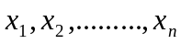are the mid-values and 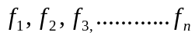 are the corresponding frequencies, where the subscript n stands for the number of classes, then the mean is
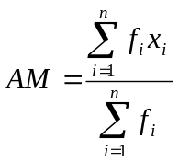
Find the Arithmetic mean.
Class | Frequency  (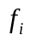) |  | 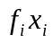
20-29 | 3 | 24.5 | 73.5
30-39 | 5 | 34.5 | 172.5
40-49 | 20 | 44.5 | 890
50-59 | 10 | 54.5 | 545
60-69 | 5 | 64.5 | 322.5
Total | N=43 |  | 2003.5

=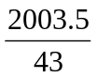=46.59
Median of Group Data 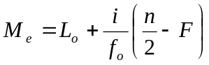
- 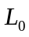 = Lower class boundary of the median Class
- i = Width of the median class/class interval.
- 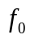 = Frequency of the median class
-  = Cumulative frequency of the pre-median class

Steps to find Median of group data

- Compute the less than type cumulative frequencies.
- Determine 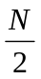 ,one-half of the total number of cases.
- Locate the median class for which the cumulative frequency is more than
- Determine the lower limit of the median class. This is.
- Sum the frequencies of all classes prior to the median class. This is F.
- Determine the frequency of the median class. This is.
- Determine the class interval of the median class. This is i.

Find Median (for group data)

Age in years | Number of births | Cumulative number of births
14.5-19.5 | 677 | 677
19.5-24.5 | 1908 | 2585
24.5-29.5 | 1737 | 4332
29.5-34.5 | 1040 | 5362
34.5-39.5 | 294 | 5656
39.5-44.5 | 91 | 5747
44.5-49.5 | 16 | 5763
All ages | 5763 | -

, here n=5763
=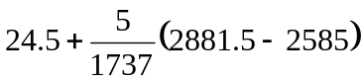=25.35
Mode of Group Data

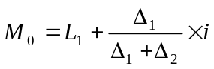

-  = Lower boundary of modal class
- 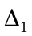= difference of frequency between modal class and class before it
- 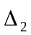= difference of frequency between modal class and class after
- i = class interval

Steps of Finding Mode

- Find the modal class which has highest frequency
- = Lower class boundary of modal class
- = Interval of modal class
- = difference of frequency of modal class and class before modal class
- = difference of frequency of modal class and class after modal class

Example: Find Mode (group data)

Slope Angle (°) | Frequency (f)
0-5 | 6
5-10 | 12
10-15 | 7
15-20 | 5
20-25 | 0

=5+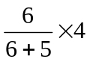
=7.18

